Procedure for Utilizing PSS®MUST to Assess Inter-Regional Transfers Specified for the Three (3) Future Scenarios Developed as part of Phase II of the EIPC Project
The EIPC is currently evaluating three (3) future scenarios developed by the stakeholders to determine transmission options needed to accommodate the projected load and resource assumptions as specified by the NEEM macroeconomic model. Given the drastic changes specified to the entire Eastern Interconnection (EI), the EIPC intends to utilize DC analyses to determine the major Extra High Voltage (EHV) constraints. Once sufficient transmission options are developed and tested to mitigate the EHV constraints identified, the large scale inter-regional transfers specified by the NEEM model will be incrementally added to the load flow case maintaining a solved load flow case.
The following procedure outlines the process by which the EIPC will perform a simultaneous DC linear transfer to simulate all of the inter-regional transfers between the NEEM regions. The FCITC report produced by MUST will then be converted to estimated thermal loadings on facilities across the EI. The initial analyses will focus on taking contingencies and monitoring EHV facilities 300 kV and above. Subsequent analyses will evaluate the lower voltage facilities. This process will also be used in an iterative approach to test potential transmissions options recommended to mitigate the identified constraints.
Step 1: Select the appropriate load flow case to be analyzed and the corresponding subsystem, monitored elements, and contingency files provided by the EIPC. For this example, the EIPC utilized the 1) Scenario 1, Block 1 – Pass_1 load flow case made available to the stakeholders on March 19, 2012, 2) a subsystem file (EIPC_S1B1_Pass_1_03202012.sub) containing specific generator buses to participate in the transfers, 3) a monitored element file (EIPC.mon) specifying all elements in the EI =>300 kV, and 4) a contingency file (EIPC.con) specifying contingencies of every branch within the EI => 300 kV.
Select the appropriate load flow case
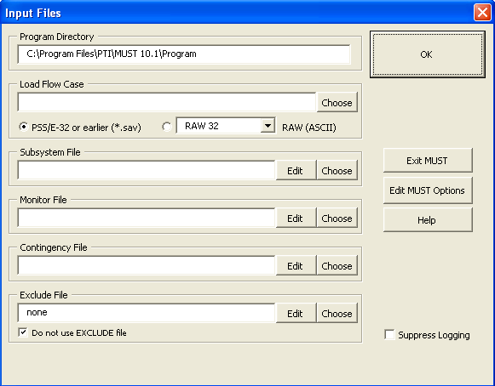
Select the appropriate .sub, .mon, and .con files

Step 2: Select “Edit MUST Options” and set the program to the specified parameters detailed below.
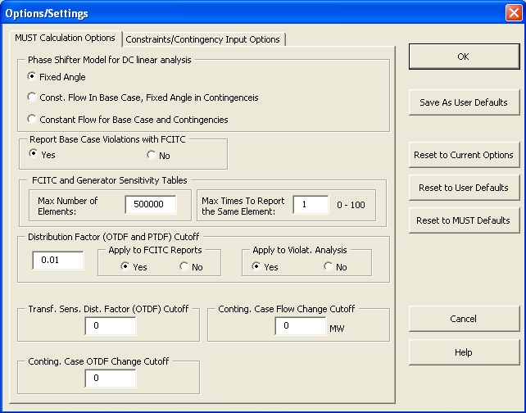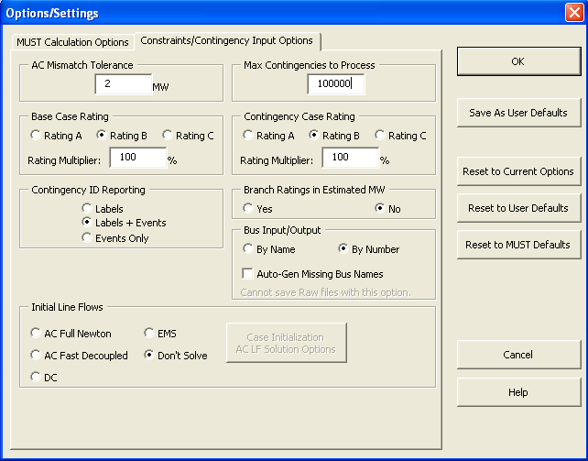
Step 3: After setting the appropriate parameters and selecting “OK”, select the option of “Single Transfer” found on the “Transfer Limit Analysis” tab.
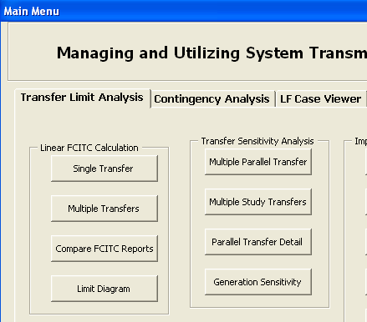
Step 4: Perform a single transfer from the subsystem “SOURCE” to “SINK” for the amount specified at the beginning of the subsystem file. For this example, the transfer amount was 86435 MW. Also, the report format must be set to “Wide”.
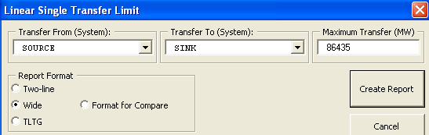

Step 5: After the report is created, select the entire report and copy the data.
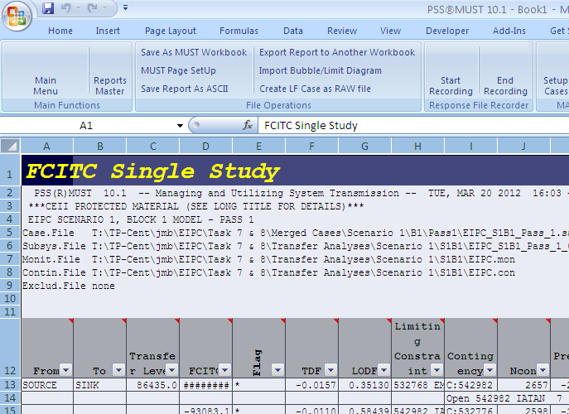
Select all cells in the spreadsheet and copy the data.
Step 6: Paste the copied data into cell “A1” of the spreadsheet titled “Convert_MUST_FCITC_to_Thermal_Loadings.xlsm” and press the “Format Data” button. This spreadsheet contains a macro that will convert the FCITC report produced by MUST into estimated thermal loadings for the identified facilities. The output report should look similar to the below picture:
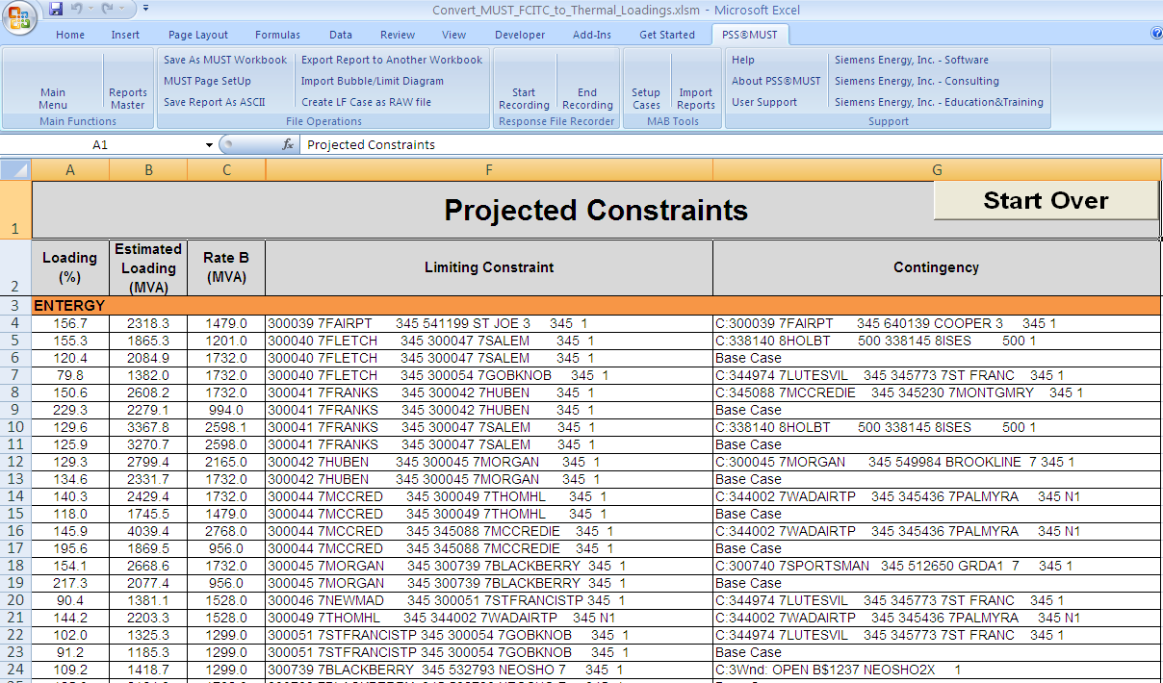
Step 7: After potential transmission options are developed to mitigate the identified constraints, the transmission options will be added to the load flow case and the above process will be utilized to assess the feasibility of the proposed options.

